**Final Project Check-in #1**

**Email mangement system**

**Introduction**

Mailing services gives free web based electronic mail. Mailing Services enables you to acquire new customers and to increase growth opportunities with existing customers. With a wide range of Direct Mail Lists Services, label mailing or mail merge services, we enable you to communicate with customers in a better way.

**Unit-Testing**

Following line of Code will use for unit testing of the Email System.

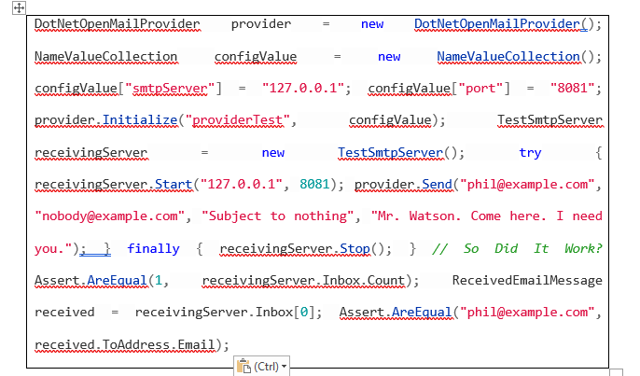

That code establishes a mail server, sends an email to it, and afterwards checks to see if the email was delivered. It also validates the to url rapidly.

This is a portion of a real unit test from the Subtext codebase.

Ivar Lumi's wonderful.NET-based free mail server was found a long time ago. I decided to create a shell that would only be used in unit testing circumstances. In the Subtext VS.NET solution, I moved the TestSmtpServer to a new project entitled Subtext.UnitTesting.Servers.

Incoming SMTP emails are parsed by the wrapper, which then adds a ReceivedEmailMessage object to the Inbox customized collection. This makes examining the e mails sent via SMTP in your unit test a breeze.

There are some important limitations because this is a very early draught. In the object model, I have yet to incorporate multi-part emails and attachments. Handling with several to addresses was also a no-go for me. The RawSmtpMessage attribute of the ReceivedEmailMessage class, on the other hand, can be examined. For the time being, it works great for simple text-based emails.

As the need arises, I hope to develop these more complex testing capabilities over time. Nevertheless, if you find this beneficial and want to help, please do so!

Check out these methods for obtaining the most recent Subtext code via Subversion if you want to see the most recent code.

Alternatively, you may high speed this one application there; however, keep in mind that I will be upgrading this work, but not always this link.

I decided to go ahead and integrated the test suite for this service within the project using its own MbUnit referencing because the application is primarily for unit experimental purposes.

**GUI**

The login Page for the email mangment system we created is shown below.

**Login Page GUI**

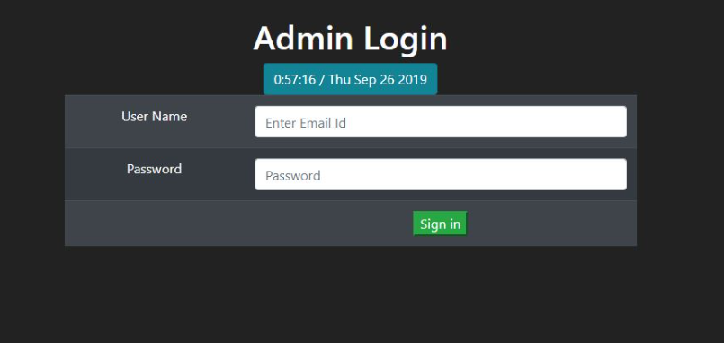

**Mail Page GUI**

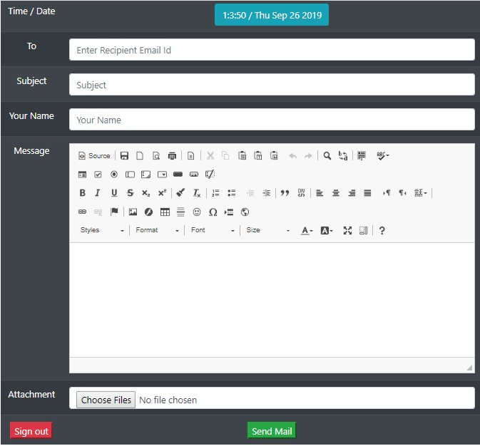

**Code:**

<html>

<head>

<title> Admin - login required</title>

<meta name="viewport" content="width=device-width, initial-scale=1.0">

<link href="../favicon.png" rel="icon" type="image/png"/>

<link href="loginview.css?family=Arimo|Rajdhani|Roboto:100" rel="stylesheet">

</head>

<body bgcolor="black">

<h1 style="margin-top: 20%"><p align = "center" > <font color="white"> <b> YOU ARE NOT LOGGED IN!<br>PLEASE LOGIN TO VIEW THIS PAGE </b> </font></h1>

<h3><p align = "center" > <font color="white"> <b> <a href="index.php">Click here to login</a> </b> </font></h3>

</body>

</html>

**Data Model**

1. **Registration**

**registration**

**2.Login**

**login**

**3 Drafts**

**drafts**

**4.Outbox**

**outbox**

**5 . Themes**

**tname**

**6. Trash**

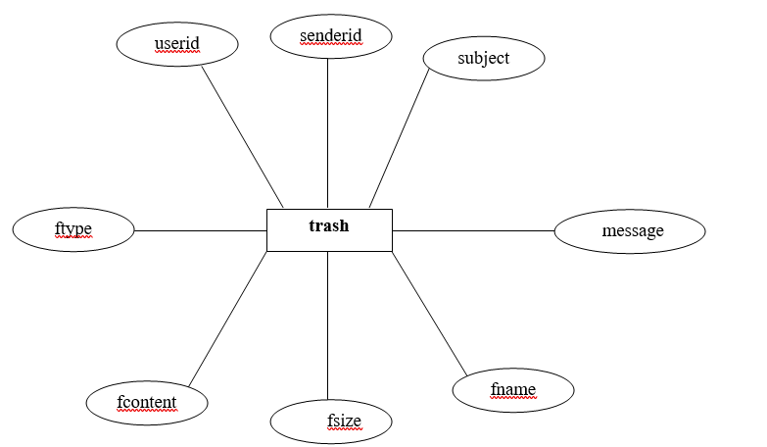

**7. Composemail**

**composemail**

**Data Attributes**

* Login
* Drafts
* Outbox
* Themes
* Trash

**Integration Tests**

As we will design the project we will do the integration tests for created pages. The integration test for the login page would be.

* Checking the interface’s link in between login page and the home page, i.e. when a user registers in and inputs their password, they should be taken to the homepage.
* Checking the interface connection between the home page and the profile page, which should open up the profile page.
* Check the interface link between the network page and your connection pages; for example, pressing the welcome option on the system page's Invitation should display the received invitation in your connection page.
* Check the ui link between the Notifications pages and the Say Congrats button, which should take you to a new notification window when you click the Say Congrats toggle.